Name: ______________________________________ | Date: ___________________


Soccer Assessment


Soccer is becoming more and more popular in the United States. And while other soccer-related injuries are happening less frequently, youth soccer players in the United States are experiencing more concussions. A concussion is a type of traumatic brain injury caused by the head experiencing an impact and moving quickly back and forth, causing the brain to bounce around in the skull.

A concussion can result from a force of 400–1,000 N on the head. There has been debate in different sports about how to best prevent concussions. In soccer, one idea is to ban headers (when a ball makes contact with a head) in youth and professional soccer.

1. How would the forces from a header with such a light soccer ball cause a concussion? Draw two free body diagrams showing how the amount of peak force on the head would compare to the amount of peak force on a soccer ball in a header that causes a collision.

There are three types of collisions that tend to happen frequently in soccer: (a) headers, (b) collisions between players’ heads, and (c) a player’s head hitting the ground.
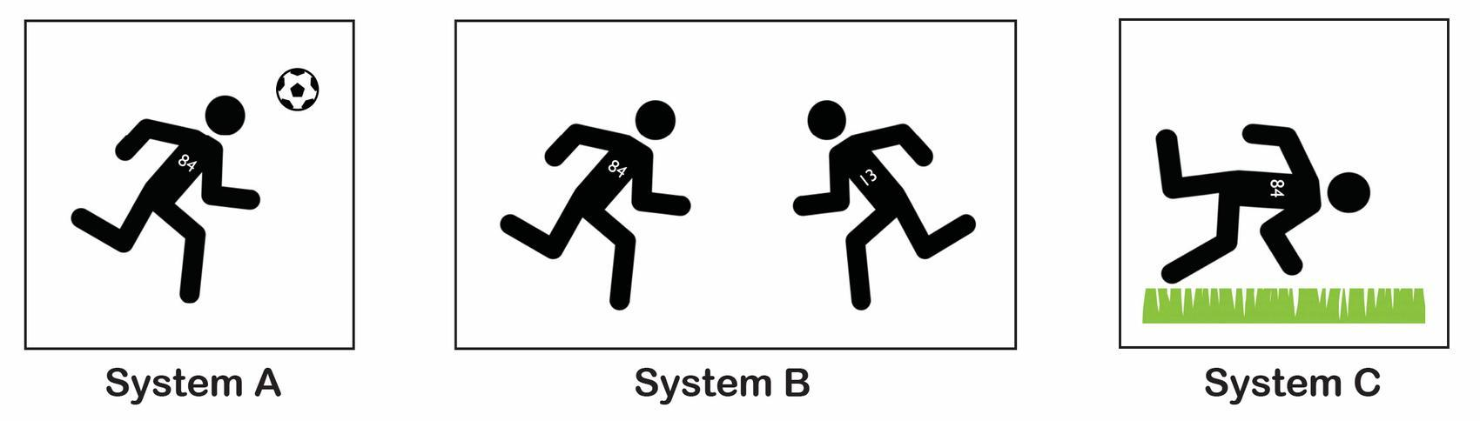

2a. How would the amount of force on the head compare to the amount of force on the object it collides with in each system A, B, and C?
- In every collision, the peak force on the head would be the same as the peak force on the other object in the collision.
- In some, but not all collisions, the peak force on the head would be the same as the peak force on the other object in the collision.
- In every collision, the peak force on the head would be different than the peak force on the other object in the collision.

2b. Explain in words or pictures your choice in 2a.

Sports scientists concluded that concussions result from headers, a running player colliding with another running player, and a running player hitting the ground. So far in this unit, we have looked at collisions and how much kinetic energy the objects in the system have before they collide and how this is related to the peak forces they can produce in any collision. Let’s consider the three main types of systems that can lead to concussions and make predictions about them using forces and energy as it relates to player #84.

3a. Considering both objects that are about to collide in each interaction, which system would you predict to have the least amount of total kinetic energy in the system right before the objects collide? In each instance below, player #84 is running at a speed of 7 miles per hour. Circle one.

- Player #84 running and heading the soccer ball that was kicked by another player
- Player #84 running and colliding with another running player running towards them
- Player #84 running and hitting the ground

3b. Explain in words and pictures using the images below why the system you chose in 3a would have the least amount of total kinetic energy before the collision by comparing it with the two other systems.

4. Based on your answer in 3b, which system should have the least amount of peak forces during the collision? Why?

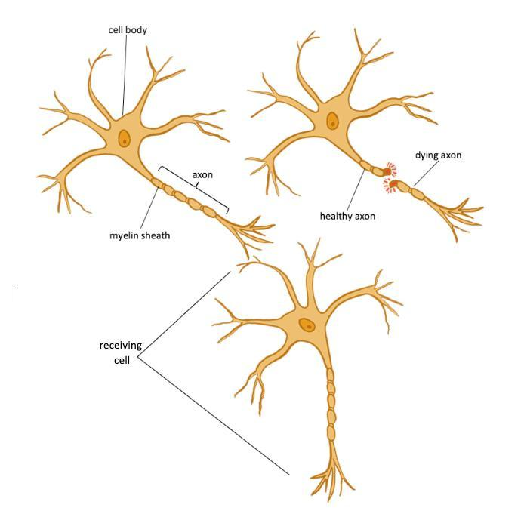

5. The brain is an organ made of interconnected cells called neurons. Neurons send signals to communicate information from one neuron cell to another. The long part of the neuron is called an axon, and those axons have a breaking point. Recent research provides evidence that permanent damage to axons in the brain occurs from just a single damaging head collision (concussion).

Write an argument: During a head collision, which system (A, B, or C) would be most likely to cause damage to some of the axons in the brain? Use ideas related to kinetic energy, peak forces, and breaking point for these structures in the brain and axons in your argument.

6. Do you think the mass of a moving object or its speed is a bigger factor contributing to its kinetic energy and the resulting damage that it can do in a collision? Why? Use any experiences you’ve had as evidence in your argument as well as any science ideas you think are relevant.

7. Suggest one or more ways we could use the materials from previous investigations to determine whether doubling the mass of a moving object or doubling its speed has a bigger effect on the amount of damage that occurs in a collision.

